SMART PARKING PLATFORM
Semester Project Document
Software Requirements Specification and Project Management Plan
Prepared by $oftware ¢orp
Elisa Castillo
October 07, 2026

Revision History
This table records every version of this document.
Version | Date | Author | Summary of Changes
0.1 | September 10, 2026 | Elisa Castillo | Initial draft. Worked on document structure, competitive analysis of existing parking platforms, the vision/scope section, and the fifteen use cases with a traceability table mapping each use case to the high level features.
0.2 | September 17, 2026 | Elisa Castillo | Added Section 6 Project Schedule: work breakdown structure to level 3, estimation basis, project timeline with Gantt chart, milestone schedule, and key dependencies. Added the work breakdown numbering convention to Section 1.3.
0.3 | September 24, 2026 | Elisa Castillo | Added Section 6.4 Product Backlog and Sprint Plan. Built the product backlog of 59 tasks across nine feature epics, derived from the use cases in Section 4.3 and the components in Section 6.1, and planned Sprint 1 around user authentication and live parking availability. Added the full backlog as Appendix A.
0.4 | September 30, 2026 | Elisa Castillo | Added Section 8 Risk Management: the approach and rating scales, and a risk register of sixteen risks, four in each of the technical, schedule, financial, and people categories. Added Sections 9.2 and 9.3, the communication plan and the reporting method by audience. Added the risk numbering convention to Section 1.3.
0.5 | October 7, 2026 | Elisa Castillo | Added Section 7 Budget, with 7.1 Resource and Cost Plan and 7.2 Budgeted Cashflow. Built a bottom up estimate priced from the twenty staff roles, and spread the total across four periods aligned to the schedule in Section 6.3. Added Sections 9.4 Roles and Resources and 9.5 RACI Matrix that assigns one accountable owner to each of the twenty five level 3 deliverables.

Table of Contents
Revision History 2
1. Introduction 4
1.1 Purpose 4
1.2 Intended Audience 4
1.3 Document Conventions 4
2. Research and Competitive Analysis 5
2.1 Approach 5
2.2 SpotHero 5
2.3 ParkWhiz 5
2.4 ParkMobile 5
2.5 Summary Comparison 6
2.6 Opportunities for Differentiation 6
3. Vision and Scope 7
3.1 The Company 7
3.2 How the Project Was Acquired 7
3.3 Business Need 7
3.4 Scope 7
3.5 Out of Scope for Now 8
3.6 Project Constraints 8
4. Software Requirements Specification 8
4.1 Overall Description 8
4.2 Actors 9
4.3 Use Cases 9
4.4 Nonfunctional Requirements 10
4.5 External Interface Requirements 10
5. Stakeholder Analysis and Management 10
6. Project Schedule 10
6.1 Work Breakdown Structure 10
6.2 Estimation Basis 12
6.3 Project Timeline 13
6.4 Product Backlog 14
6.5 Sprint 1 Backlog 14
7. Budget 15
7.1 Resource and Cost Plan 15
7.2 Budgeted Cashflow 16
8. Risk Management 16
8.1 Approach and rating scales 16
8.2 Risk register 17
9. Team Structure and Coordination 17
9.1 Delivery teams 17
9.2 Communication plan 18
9.3 Reporting method by audience 18
9.4 Roles and Resources 18
9.5 RACI Matrix 19
10. Appendices 20
11. References 20

1. Introduction

1.1 Purpose
This document defines the vision, scope, requirements, and project management plan for the Smart Parking Platform, a system that helps drivers locate, reserve, and pay for parking spaces in parking garages in real time. It is a living document. New sections are added each week and existing sections are refined until the project is complete at the end of the semester.

1.2 Intended Audience
This document is written for the stakeholders of the project including drivers and vehicle owners, parking facility operators, city transportation departments, system administrators, finance and billing personnel, and the development teams at $oftware ¢orp. Business sections are written for a non technical audience and technical sections are written for the engineering and quality assurance teams.

1.3 Document Conventions
- Version numbers follow a simple decimal scheme. Draft versions begin at 0.1 and the final submitted version will be 1.0.
- High level features carry the prefix HLR, for example HLR-01.
- Use cases carry the prefix UC, for example UC-01.
- Tables and figures are numbered in sequence and carry a caption directly below them.

2. Research and Competitive Analysis

2.1 Approach
Before defining the scope of the Smart Parking Platform, $oftware ¢orp reviewed the parking applications that drivers already use today. Three products were selected because together they represent the main models in the market: a reservation marketplace for garages, a booking service built around guaranteed spaces, and a session based payment service for on street parking. Each product was reviewed for what it does well, where it falls short, and what that gap means for this project.

2.2 SpotHero
SpotHero is the well-known parking reservation app in North America. It helps drivers look at prices near a place they are going pay ahead to save a spot and then drive to a garage, lot or valet. It says users can save up to fifty percent compared to what they would pay when they arrive covers thousands of places in cities like Houston and works with Apple CarPlay so drivers can book without using a phone. It also has business accounts that keep work parking separate from parking and send receipts to accounting systems.
Where it has problems: the spots a driver can see are the ones an owner has decided to list and sell ahead of time so what the app shows is already booked spaces, not what is actually available, inside the garage. Prices can change a lot and people who use the parking apps say rates go up a lot during busy times. The app is also mostly made for the driver. Tools that help the person who owns the garage are not a focus.

2.3 ParkWhiz
ParkWhiz follows a similar marketplace model with an emphasis on fast booking of guaranteed spaces, and it is frequently recommended alongside SpotHero for airport and event parking. Its strength is speed and certainty. A driver knows before leaving home that a specific space is held for them.
Where it falls short: it draws on much of the same aggregated inventory as its competitors, so coverage varies noticeably by city and by venue. Like SpotHero, it confirms that a reservation exists but does not tell a driver how full a garage is at this moment, and it offers little to the operator beyond a channel for selling unsold spaces.

2.4 ParkMobile
ParkMobile is the dominant application for on street and municipal parking. Drivers park, pay for a session from their phone, and extend that session remotely without returning to the meter. It is adopted widely by cities, which gives it very broad reach and strong name recognition among everyday commuters.
Where it falls short: it is designed around metered zones rather than garages, so garage reservation is not its core strength. Reviews of these applications describe notifications that arrive after a session has already expired and charges for sessions the driver believed had ended, which points to a reliability problem in the alerting and session tracking layer. Service fees added on top of the parking rate are a common source of complaints.

2.5 Summary Comparison
Criteria | SpotHero | ParkWhiz | ParkMobile
Primary focus | Garage and lot reservations | Guaranteed prebooked spaces | On street and metered sessions
Advance reservation | Yes | Yes | Limited
Live garage occupancy | No, listed inventory only | No, listed inventory only | No
Navigation support | Yes, including CarPlay | Yes | Some
Operator tools | Limited | Limited | Limited
Common complaints | Surge pricing, billing errors | Uneven coverage by market | Late alerts, added fees

2.6 Opportunities for Differentiation
- Accurate real time availability: rather than showing only the spaces an operator has listed for sale, the platform will report live occupancy from operator systems and sensor feeds, so a driver sees what is actually free right now.
- Clearer pricing: the platform will quote one total price before a driver confirms a reservation, with any fees itemized and no surprise increases at busy times.
- Reliable alerts: notifications for reservation confirmation, arrival, expiration, and payment will be tied directly to the reservation lifecycle so that a driver is warned before a session ends rather than after.
- Fourth, stronger tools for parking operators: the administrative dashboard, occupancy reporting, and analytics will be treated as a core product rather than an afterthought, giving operators the pricing and utilization insight the existing consumer apps do not provide.

3. Vision and Scope

3.1 The Company
$oftware ¢orp is a software development studio that designs, builds, and delivers complete platforms for clients in the transportation and mobility sector. The studio operates with unlimited theoretical resources and budget, which allows the project to be planned around the best solution rather than around cost. Work is delivered by six teams: mobile application, web application, backend and API, mapping and location services, payment integration, and quality assurance and testing.

3.2 How the Project Was Acquired
The Smart Parking Platform was commissioned by a regional parking operator that manages a portfolio of downtown and airport garages, working in partnership with a city transportation department. The operator had been losing revenue to unsold spaces while drivers circled the same blocks looking for parking, and the city was measuring the resulting congestion in its downtown corridors. Neither party could solve the problem with the tools available to them, since the existing consumer parking apps sell reservations but return little usable data to the facilities themselves.
The operator issued a request for proposal for a platform that would serve both audiences at once. $oftware ¢orp was selected because the proposal treated the operator dashboard and the driver application as equal halves of a single system rather than building a consumer app and adding reporting later. The engagement covers full delivery of the platform, from requirements gathering through testing and release.

3.3 Business Need
Drivers lose a significant amount of time searching for parking. The search creates congestion, wastes time that could be spent elsewhere, and adds cars to streets that are already crowded. Parking operators face the other half of the same problem, since they lack the tools to monitor how full their facilities are, to set prices against real demand, and to improve the use of the spaces they already have. A garage can sit half empty while drivers circle the block outside it, because neither side can see what the other is doing.

The Smart Parking Platform solves that problem from both directions. It shows drivers which spaces are available at that moment, lets them reserve and pay before they arrive, and guides them to the space itself. It gives operators a live view of occupancy, control over their pricing, and reports that show how their facilities are actually used.

3.4 Scope
The first version of the Smart Parking Platform lets drivers and parking operators create accounts, verify their identity, and sign in securely. Drivers see the spaces available at participating garages on an interactive map, select a date and time, reserve a space, and pay for it with the digital payment methods built into the platform. The platform keeps a record of every reservation, makes receipts available, and sends confirmations, arrival alerts, and reminders when a reservation is close to expiring.

Parking operators receive a dashboard that manages their facilities, updates availability, adjusts pricing, and reports on occupancy, utilization, demand patterns, and revenue. The platform also connects to external navigation services, so drivers receive directions to the garage they reserved.

3.5 Out of Scope for Now
- On street metered parking, parking zones, and municipal enforcement or citations.
- Electric vehicle charging reservation, metering, and billing.
- Valet services and attendant managed parking.
- Peer to peer sharing of private driveways and residential spaces.
- Manufacture of physical hardware such as occupancy sensors, cameras, and gate equipment. The platform integrates with this equipment but does not produce it.
- Monthly parking permits, corporate accounts, and subscription contracts.
- Autonomous vehicle self parking and automated valet features.

3.6 Project Constraints
- The development budget is theoretically unlimited, so scope is not constrained by cost.
- The timeline is fixed to the length of the semester and cannot be extended.
- The platform depends on third party services and APIs for mapping, navigation, and payment.
- The platform must comply with security and privacy requirements as well as applicable city ordinances and laws.

4. Software Requirements Specification

4.1 Overall Description
The Smart Parking Platform is a new system and does not replace an existing product at the operator or the city. It presents two faces on one shared backend. Drivers use a mobile and web application to find, reserve, and pay for a space, and parking operators use a dashboard to manage facilities, pricing, and reporting. Then, a space sold to a driver leaves the operator view in the same moment.
Product perspective: A web and mobile platform on a shared backend, integrated with external mapping, navigation, and payment services and with the sensor and gate equipment already installed in participating garages.
Major functions: Account registration and secure sign in, parking search, live availability, reservation, digital payment, navigation to the garage, entry validation, reservation extension and cancellation, history and receipts, notifications, facility and pricing management, and occupancy and revenue analytics.
User classes: Drivers use the platform occasionally and receive no training, so the driver application has to work on the first attempt. Operators use it daily and need depth over simplicity. Finance and billing staff and system administrators use a narrow set of functions with elevated permissions.
Operating environment: iOS and Android for the driver application, current desktop and mobile browsers for the operator dashboard, and cloud hosted backend services.
Design constraints: Card data is held by the payment provider rather than by the platform. Location history is retained only for the period agreed with the city transportation department.
Assumptions and dependencies: Participating garages supply live occupancy data from their own equipment. Mapping, navigation, and payment are supplied by third parties under contract. Drivers carry a smartphone with location services enabled.

4.2 Actors
Primary actors
- Driver: Registers, searches for parking, reserves a space, pays, navigates to the garage, enters, extends or cancels, and retrieves receipts. The driver appears in twelve of the fifteen use cases.
- Parking Operator: Maintains facility details, availability, and pricing, and reads occupancy and revenue analytics from the dashboard.
- Finance and Billing Employee: Issues full or partial refunds for disputed charges and reconciles payouts to operators.
- System Administrator: Manages accounts, roles, and permissions, and monitors the health of the platform.
Secondary actors
- Payment Provider: Authorizes, captures, and refunds transactions, and holds card data on behalf of the platform.
- Mapping and Navigation Service: Supplies base maps, geocoding, and routing to the reserved garage.
- Garage Sensor and Gate System: Reports occupancy counts and entry and exit events, and validates a reservation at the gate.
Note: The city transportation department is a stakeholder rather than an actor. It receives aggregate reporting through the operator and does not sign in to the platform in the first version.

4.3 Use Cases
Account Registration - As a driver, I want to create and verify an account so that I can securely use the parking platform.
Secure Sign In - As a driver or parking operator, I want to sign in securely so that I can access the features and information for my role.
Parking Search - As a driver, I want to search for parking near a destination so that I can quickly find a convenient garage.
Real Time Availability - As a driver, I want to view current garage availability so that I can choose a location with open spaces.
Parking Reservation - As a driver, I want to reserve a parking space for a selected time so that a space is available when I arrive.
Digital Payment - As a driver, I want to pay for a reservation digitally so that I can confirm my booking before arriving.
Garage Navigation - As a driver, I want directions to my reserved garage so that I can reach the correct entrance without unnecessary delays.
Entry Validation - As a driver, I want my reservation validated at the garage entrance so that I can enter quickly and begin my parking session.
Reservation Extension - As a driver, I want to extend an active reservation so that I can remain parked longer without receiving an overstay charge.
Reservation Cancellation - As a driver, I want to cancel an upcoming reservation so that the space can be released and any eligible refund can be processed.
Reservation History and Receipts - As a driver, I want to view my reservation history and retrieve receipts so that I can review and document my parking expenses.
Notification Preferences - As a driver, I want to configure notification preferences so that I receive useful confirmations, reminders, and expiration warnings through my preferred channel.
Facility and Pricing Management - As a parking operator, I want to manage facility details and pricing so that drivers receive accurate information and rates.
Occupancy and Revenue Analytics - As a parking operator, I want to view occupancy and revenue analytics so that I can improve facility utilization and pricing decisions.
Disputed Charge Refund - As a finance and billing employee, I want to issue a full or partial refund for a disputed charge so that valid billing problems can be resolved and recorded.

4.4 Nonfunctional Requirements

4.5 External Interface Requirements

5. Stakeholder Analysis and Management
- Drivers and vehicle owners
- Parking facility operators
- City transportation departments
- System administrators
- Finance and billing personnel
- Mobile application users
- Third party payment providers

6. Project Schedule
This section presents the work breakdown structure for the Smart Parking Platform and the schedule that is derived from it. The breakdown decomposes the platform into deliverables, the schedule places those deliverables into weeks, and the milestone table marks the points at which a group of deliverables is complete. The schedule covers fifteen working weeks. Week 1 begins Thursday August 27, 2026 and week 15 ends Wednesday December 9, 2026.

6.1 Work Breakdown Structure
1. Project Initiation and Planning
- 1.1 Requirements Elicitation
  - 1.1.1 Stakeholder Interviews
  - 1.1.2 Competitive Analysis
  - 1.1.3 Requirements Workshop with Operator and City
- 1.2 Vision and Scope Document
- 1.3 Software Requirements Specification
  - 1.3.1 Use Case Catalog
  - 1.3.2 Nonfunctional Requirements
- 1.4 Project Management Plan
  - 1.4.1 Work Breakdown Structure and Schedule
  - 1.4.2 Risk Register
  - 1.4.3 Communication Plan
- 1.5 Kickoff and Baseline Approval
2. System Design
- 2.1 Architecture Design
  - 2.1.1 Service and Interface Contract Design
  - 2.1.2 Database Schema Design
  - 2.1.3 Availability Data Model
- 2.2 Interface Design
  - 2.2.1 Driver Application Wireframes
  - 2.2.2 Operator Dashboard Wireframes
  - 2.2.3 Interactive Map Design
- 2.3 Security and Compliance Design
  - 2.3.1 Authentication and Authorization Model
  - 2.3.2 PCI DSS Scope Definition
  - 2.3.3 Data Retention Policy
3. Development
- 3.1 Backend and API Services
  - 3.1.1 Account and Authentication Service
  - 3.1.2 Availability Service
  - 3.1.3 Reservation Engine
  - 3.1.4 Notification Service
  - 3.1.5 Analytics and Reporting Service
- 3.2 Driver Application
  - 3.2.1 Registration and Sign In
  - 3.2.2 Parking Search and Interactive Map
  - 3.2.3 Reservation and Checkout
  - 3.2.4 Reservation History and Receipts
- 3.3 Operator Dashboard
  - 3.3.1 Facility and Pricing Management
  - 3.3.2 Live Occupancy View
  - 3.3.3 Occupancy and Revenue Reports
- 3.4 Mapping and Location Services
  - 3.4.1 Provider Abstraction Layer
  - 3.4.2 Geocoding and Garage Search
  - 3.4.3 Navigation Handoff
- 3.5 Payment Integration
  - 3.5.1 Hosted Payment Page and Tokenization
  - 3.5.2 Refund and Cancellation Handling
  - 3.5.3 Operator Payout Reconciliation
- 3.6 Sensor and Gate Integration
  - 3.6.1 Occupancy Feed Ingestion
  - 3.6.2 Entry Validation at the Gate
4. Testing
- 4.1 Unit Testing
- 4.2 Integration Testing
- 4.3 Load and Stress Testing
- 4.4 Security and Penetration Testing
- 4.5 User Acceptance Testing
5. Deployment
- 5.1 Environment Setup
- 5.2 Pilot Deployment to Two Garages
- 5.3 Production Release
6. Project Closure
- 6.1 Operator and Staff Training
- 6.2 Documentation Handover
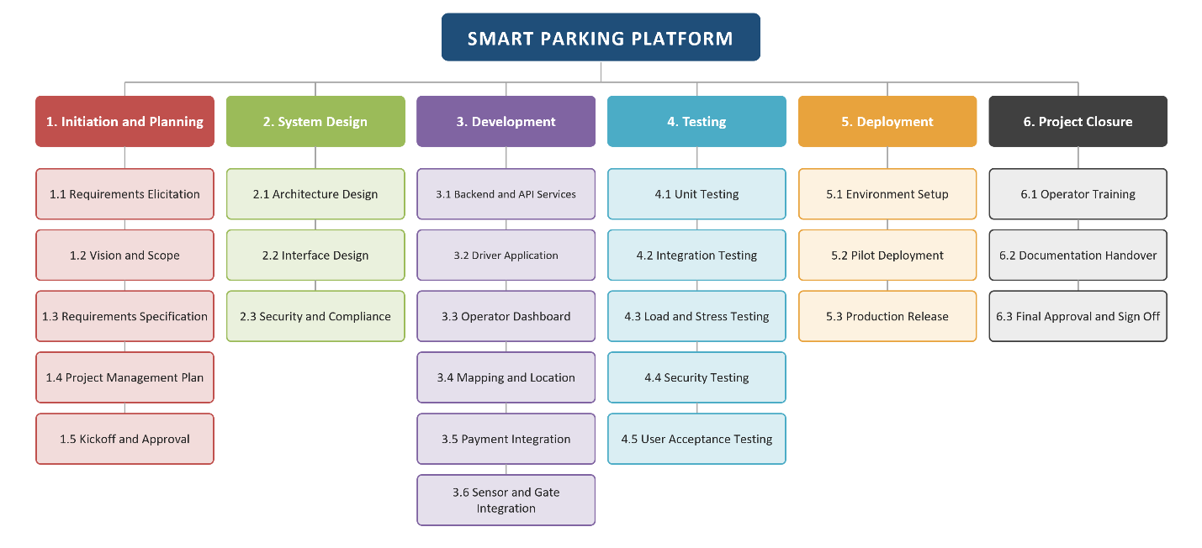
- 6.3 Final Approval and Sign Off

6.2 Estimation Basis
Effort was estimated before the schedule was built. Each level 4 activity was sized in story points on the Fibonacci scale by the team that owns it, and those values were calibrated by analogy to earlier projects of comparable scope delivered by the studio. Story points measure complexity, risk, and effort rather than hours, so the conversion into calendar weeks was made afterward, once team assignments were known.
- Level 4 activities are the estimating unit. Level 5 tasks refine an activity and do not add to its total.
- Point values were calibrated by analogy to earlier studio projects of comparable scope.
- The development budget is theoretically unlimited, so staffing is not the constraint on the schedule. The fixed semester window is.
- Durations assume the six delivery teams work in parallel on their own branches, as described in Section 9.
- Estimates are revisited at every milestone, and any revision is recorded in the revision history at the front of this document.

6.3 Project Timeline
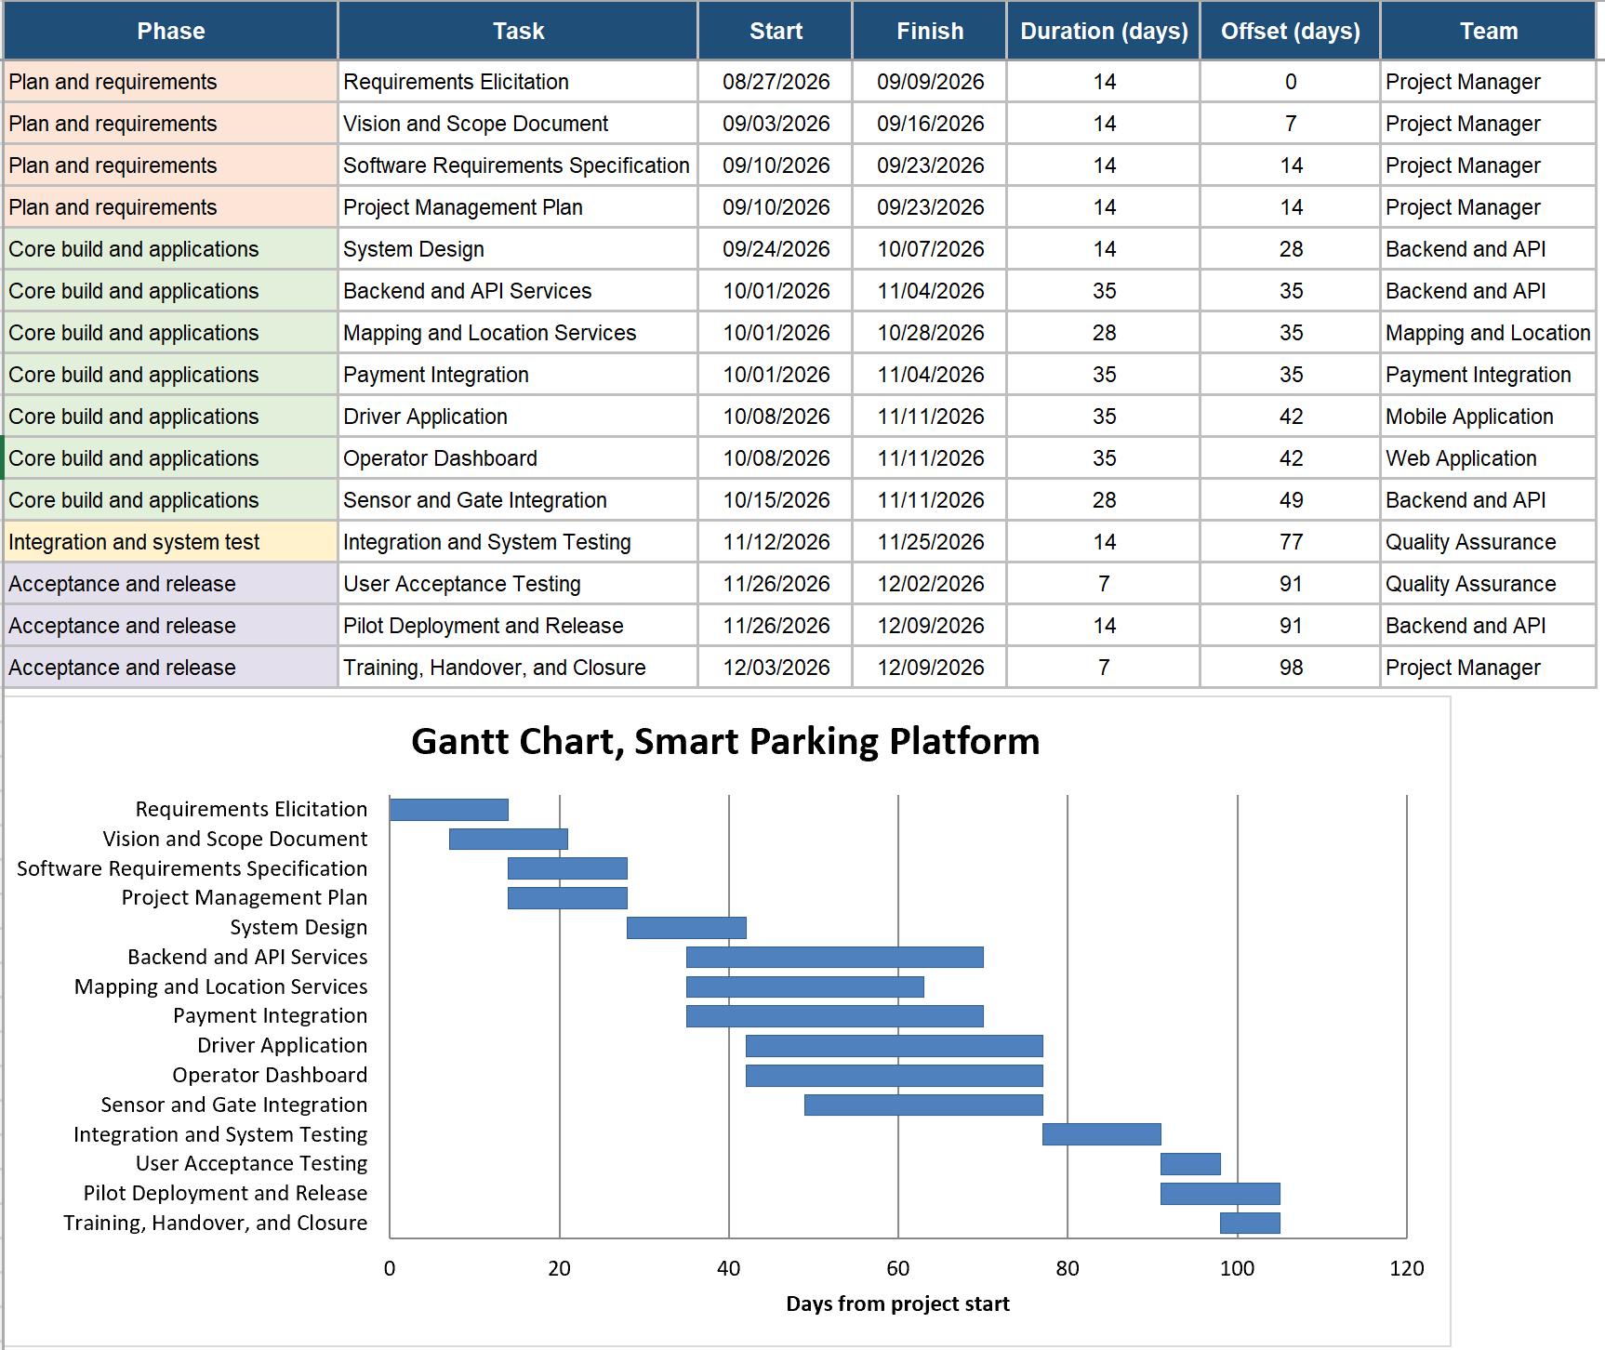
The schedule runs for fifteen working weeks and is grouped into four phases. The phases overlap only at their boundaries, so each one ends at a milestone that can be reviewed before the next begins.
Phase | Weeks | Dates | Focus
Plan and requirements | W1 to W4 | Aug 27 to Sep 23 | Stakeholder elicitation, use cases, risk and budget register, SRS baseline
Core build and applications | W5 to W11 | Sep 24 to Nov 11 | Backend services, driver application, operator dashboard, mapping and payment integration
Integration and system test | W12 to W13 | Nov 12 to Nov 25 | End to end integration, load and stress testing, security and penetration testing
Acceptance and release | W14 to W15 | Nov 26 to Dec 9 | User acceptance testing, defect triage, pilot deployment, training and handover

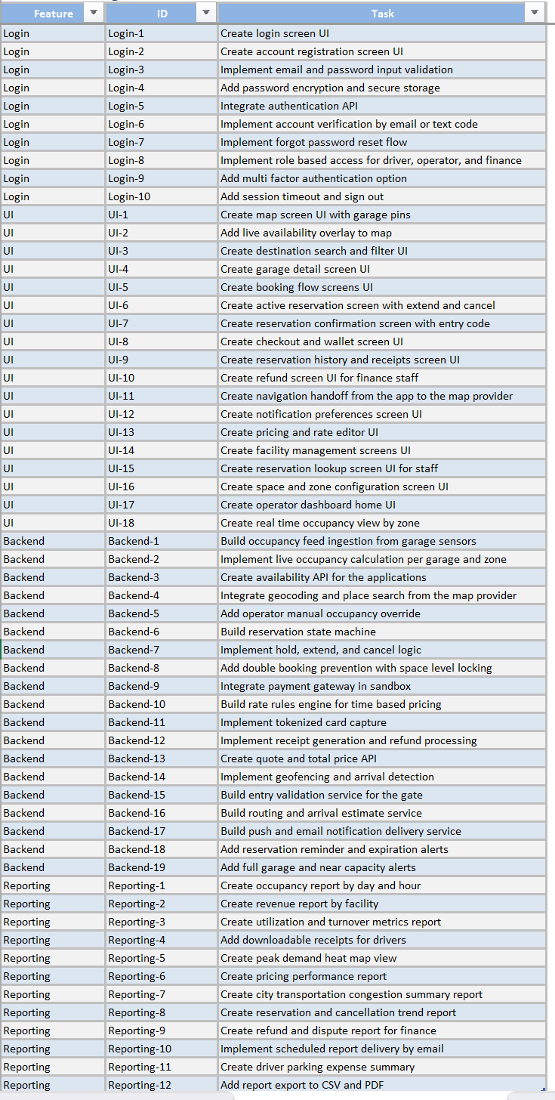
6.4 Product Backlog

6.5 Sprint 1 Backlog

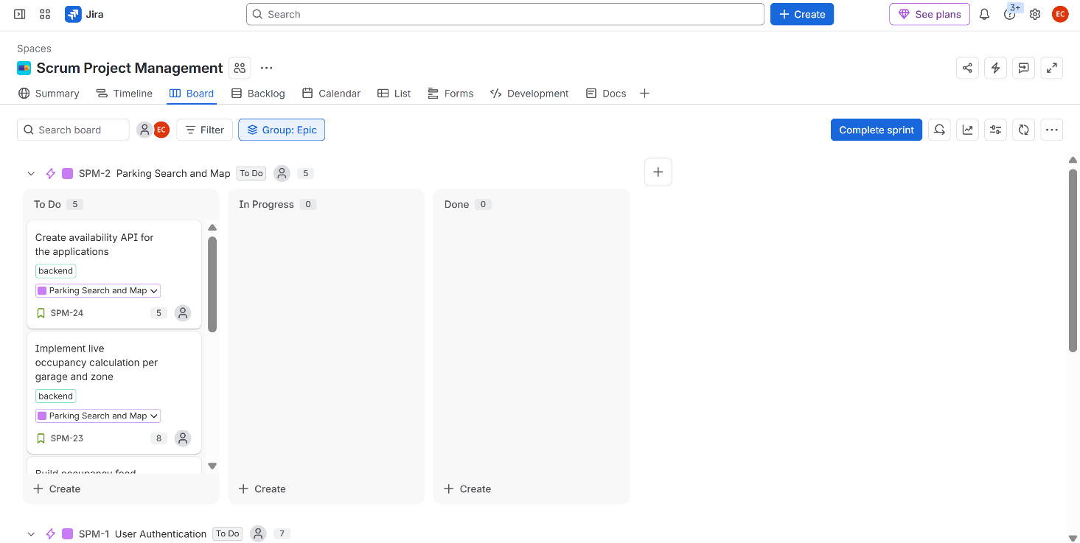
7. Budget
This section presents the cost of building the Smart Parking Platform and the schedule on which that cost is spent. The resource plan prices the team, the cost plan adds everything the team consumes, and the cashflow distributes the total across the fifteen week schedule. The budget is not a constraint on this project, since Section 3.6 sets it as theoretically unlimited, so the figure here exists to tell the operator what the platform cost to build rather than to cap what gets built.

7.1 Resource and Cost Plan
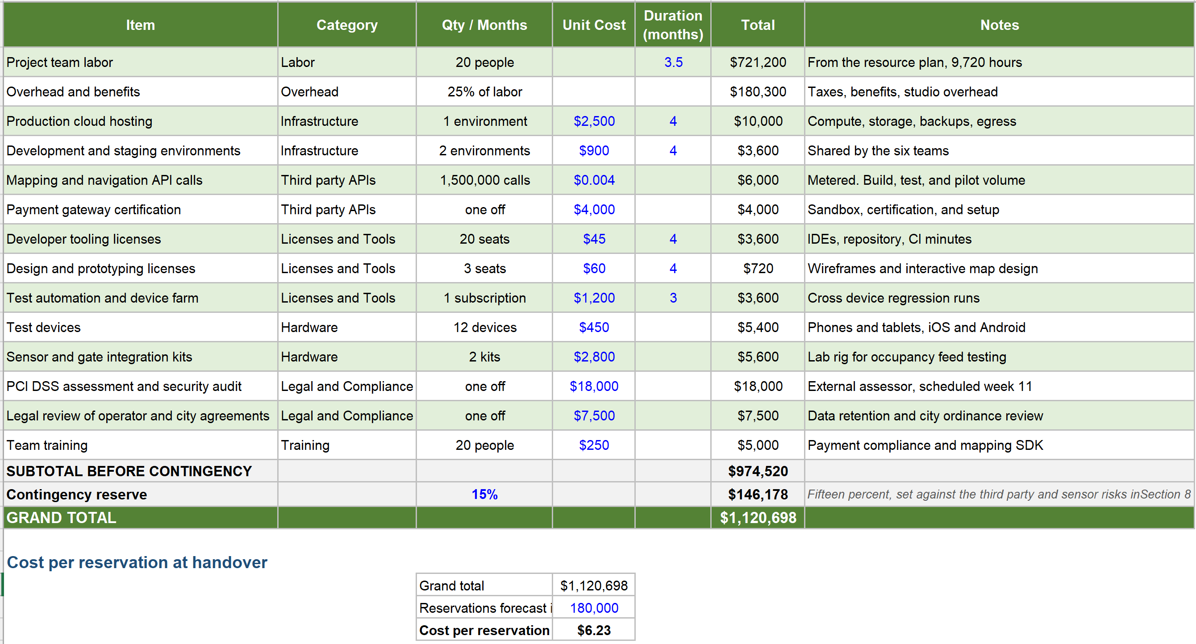
The estimate is built from the bottom up. Every line carries its own quantity and unit cost and the lines are summed, so each number traces back to the work package or purchase that produced it. Labor is priced from the roles in Section 9.4. Overhead is applied at twenty five percent of labor, and a contingency reserve of fifteen percent is added last, set above the middle of the usual range because the platform depends on third party mapping, payment, and sensor services.

7.2 Budgeted Cashflow
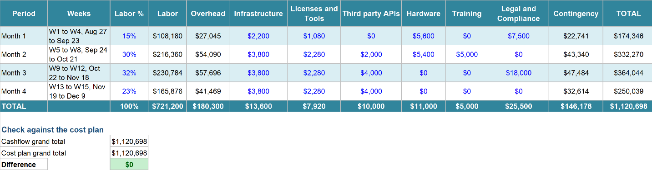
The total is spread across four periods of roughly four weeks, aligned to the phases in Section 6.3, so each period can be read against the work it pays for. Labor follows the staffing ramp such as light while the team is still eliciting requirements, full through the build, and tapering across the release weeks. Non labor costs land in the period that triggers them, which is why the compliance assessment sits in period three. The cashflow total and the cost plan total agree, and the check at the foot of the table confirms it.

8. Risk Management
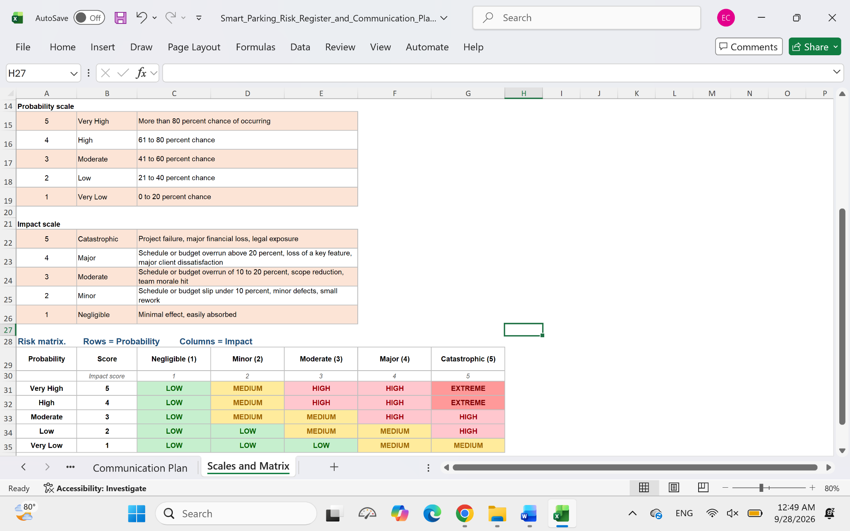
This section presents the risk management approach for the Smart Parking Platform and the register that is derived from it. The rating scales assign a probability and an impact to every risk, the matrix converts that pair into a single risk level, and the register records the response strategy, the owner, and the current status for each entry. Sixteen risks are recorded, four in each of the four categories the project tracks: technical, schedule, financial, and people. The register is baselined at the end of the plan and requirements phase in week 4 and is reviewed every two weeks, so probability and impact are rescored as the project moves through the phases in Section 6.3.

8.1 Approach and rating scales
Every risk is scored on two five point scales, one for the probability that it occurs and one for the impact if it does. The two scores meet in a five by five matrix that resolves them into a single level of low, medium, high, or extreme, so a rare risk with severe consequences and a frequent risk with minor ones do not end up at the same priority. Each risk is then given one of four responses: avoid, mitigate, transfer, or accept.

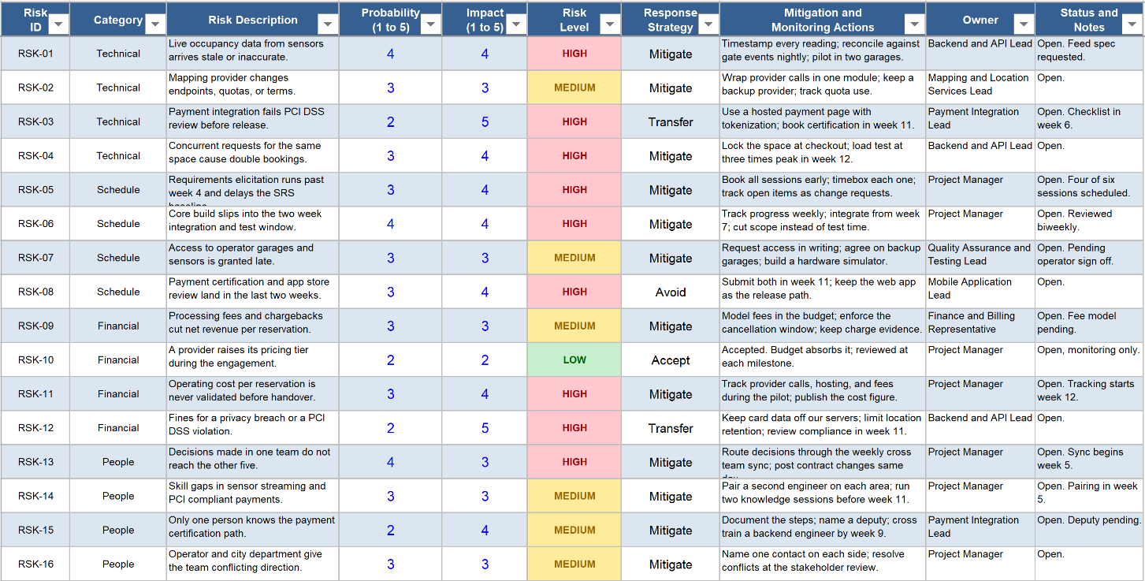
8.2 Risk register

9. Team Structure and Coordination
The Smart Parking Platform is delivered by six teams working in parallel, so information has to move between them on a fixed rhythm rather than on demand. This section names those teams, sets the meeting cadence each one follows, and defines what every audience receives and through which method. Counting the six team leads and the project manager, the project carries twenty one channels at the coordination level, so cross team decisions are made at a single weekly sync and the detail inside each team stays inside its own standup.

9.1 Delivery teams
- Mobile Application Team
- Web Application Team
- Backend and API Team
- Mapping and Location Services Team
- Payment Integration Team
- Quality Assurance and Testing Team

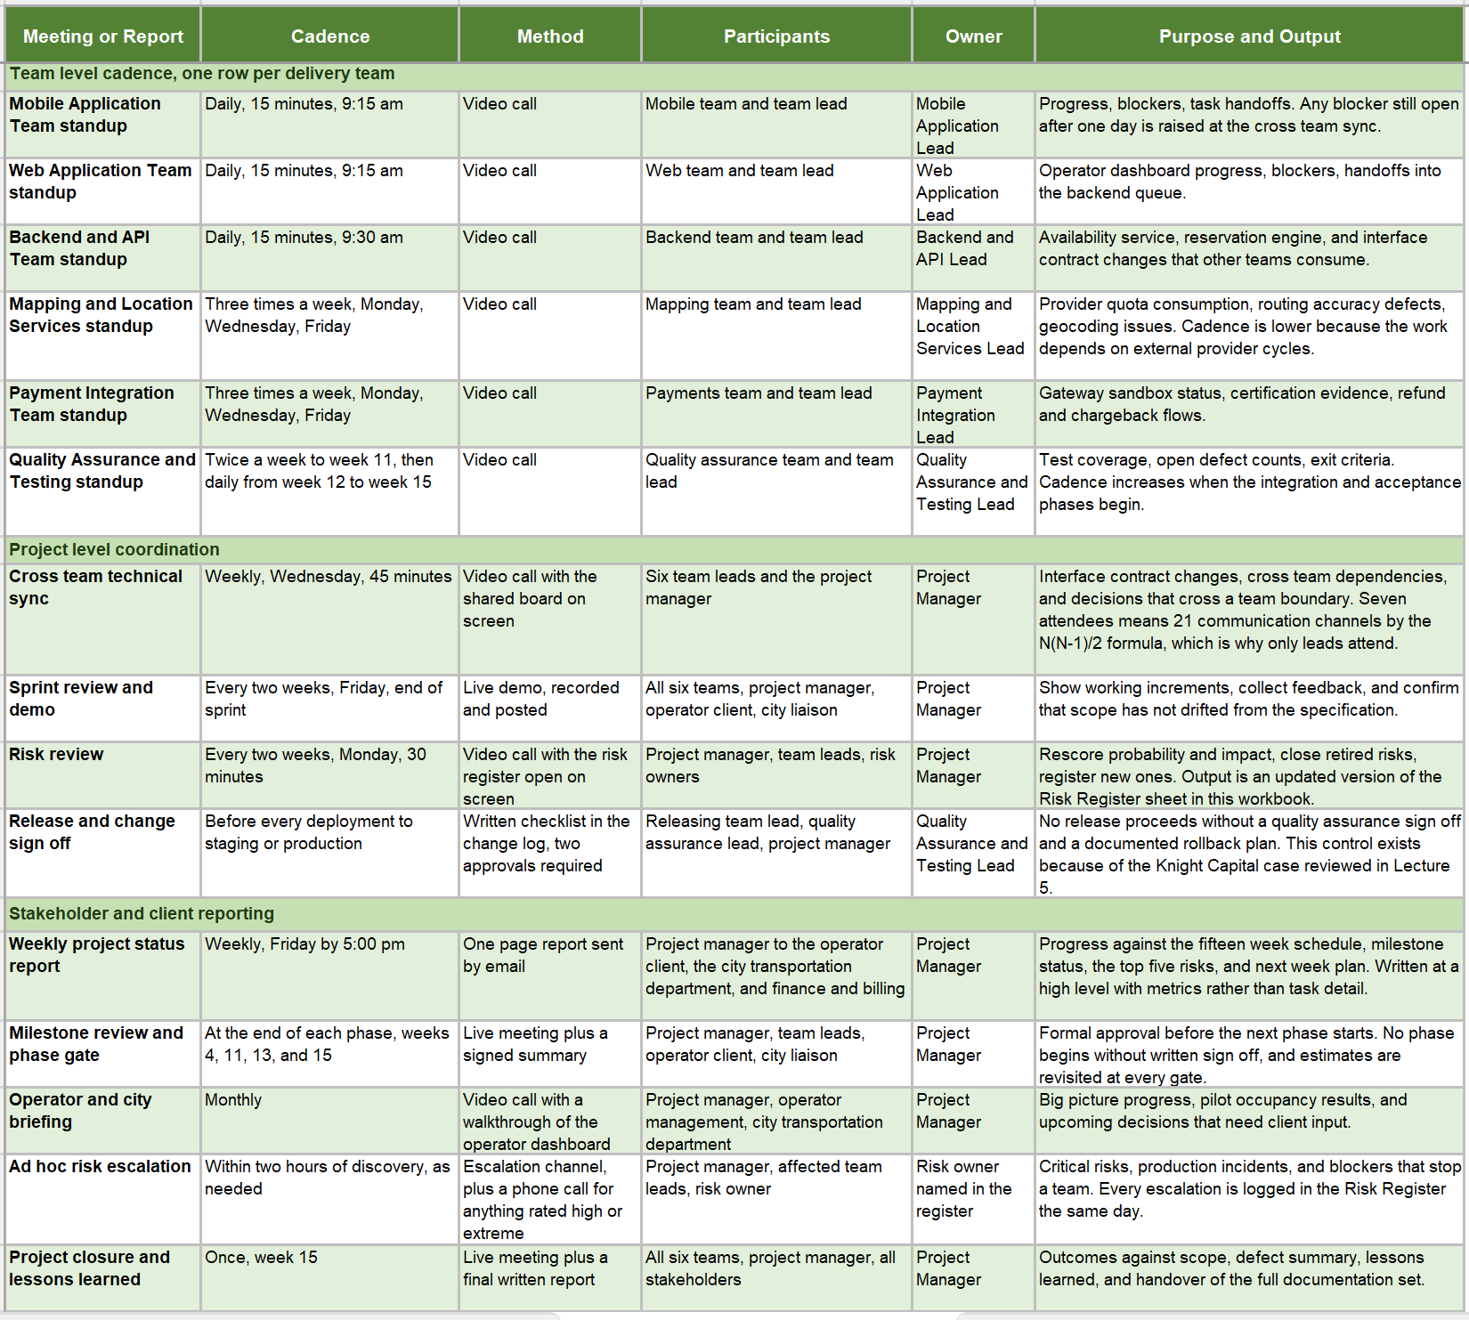
9.2 Communication plan

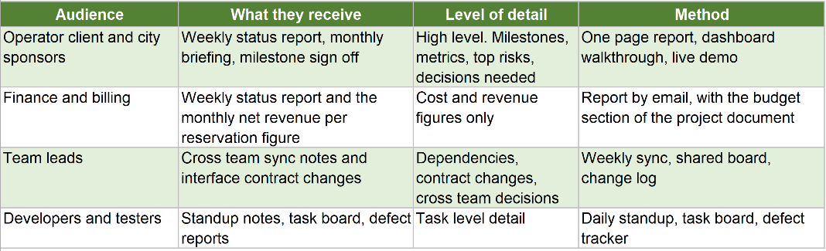
9.3 Reporting method by audience

9.4 Roles and Resources

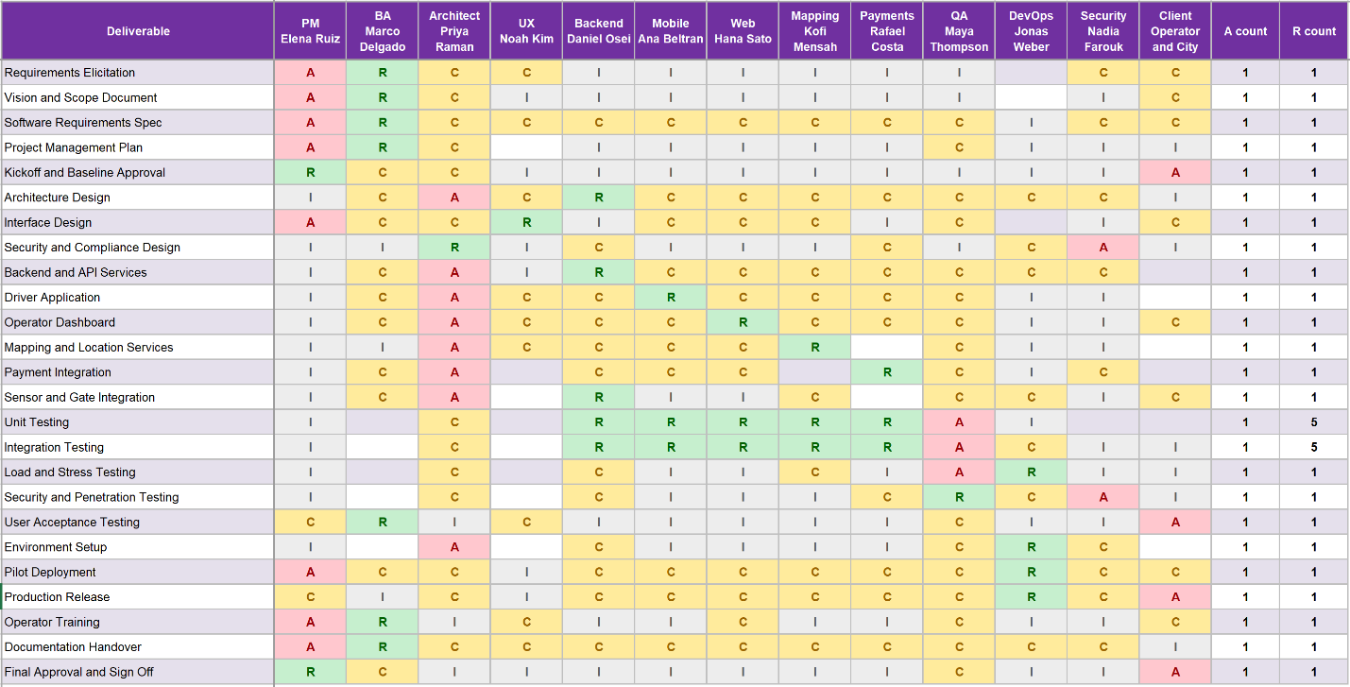
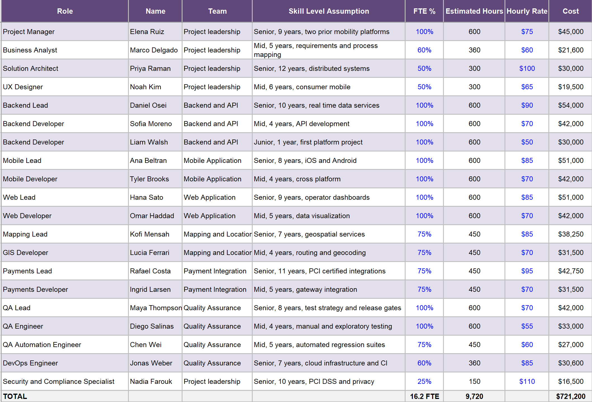
9.5 RACI Matrix

10. Appendices

11. References
https://spothero.com/
https://apps.apple.com/us/app/spothero-1-rated-parking-app/id499097243
https://winsparking.com/compare/parkwhiz
https://www.parkwhiz.com/how-it-works/
https://www.flashparking.com/demand-network/
https://parkmobile.io/parking/how-reservations-work
https://unstar.app/es-ES/blog/parkmobile-spothero-paybyphone-parkwhiz-passport-parking-apps-ranked-2026

